Lesson 3 adding a context and provider

Shared data for theme 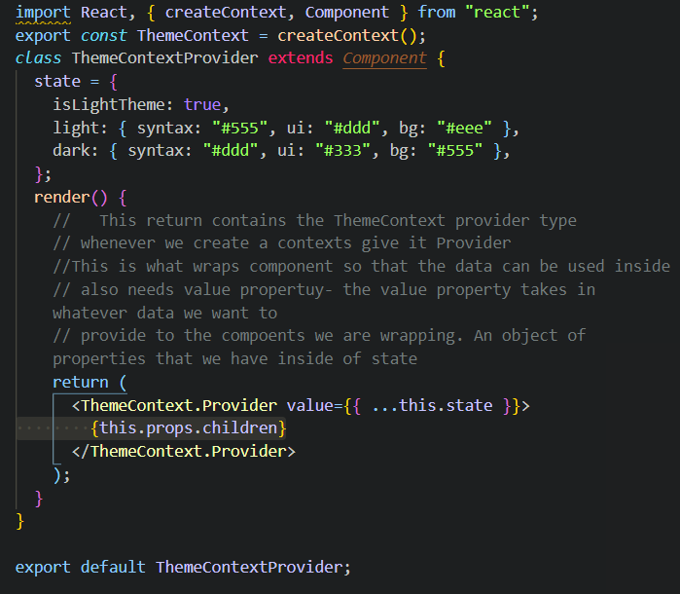

Then import into App.js to surround Navbar and Booklist 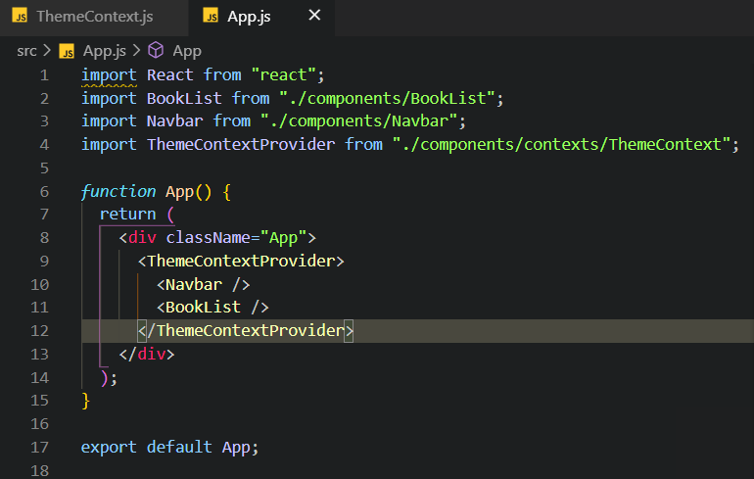

Using dev tools can see

